[1]

Results on Active Damping Control of a Thin-Walled Rotating Cylinder with Piezoelectric Patch Actuation and Sensing*

Ziv Brand and Matthew O.T. Cole

*Abstract*—This paper describes research on the active control of vibration in thin-walled cylindrical structures under rotation. Enhanced damping of flexural vibration may be achieved through feedback control of embedded piezoelectric patch actuators. To assess the interaction of wall vibration with actuator and sensor operation, a theoretical model of a rotating annulus is considered. This model describes the multi-mode travelling wave behavior for circumferential vibration. It is seen that, due to rotational symmetry, use of only a single actuator will lead to one of each pair of degenerate modes being uncontrollable in the non-rotating case. However, as rotational speed increases, full controllability is recovered. This is due to the transition under rotation from standing mode to travelling wave characteristics for the vibration. Experiments were conducted on a short thin-walled steel cylinder (diameter 224 mm). A collocated actuator/sensor (piezoelectric patch) pair was applied with a control law based on resonant filters to achieve enhanced damping of circumferential vibration modes up to third order (natural frequencies: 161, 443, 846 Hz). A second actuator/sensor pair was used to assess controllability and the effectiveness of the active damping control loop. The results confirm the suitability of the theoretical models and qualitative predictions of the speed-dependent control influence for the actuator/sensor pairs.

# INTRODUCTION

Thin-walled cylindrical and ring-like structures form vital components in a wide range of engineering systems. The vibration behavior of a thin-walled cylinder under rotation is pertinent to the design and operation of rotor-bearing systems, wheel and tire systems, gear transmissions and some types of machining processes, among other applications.

The vibrational dynamics of cylindrical and conical elements can be described analytically using shell theories. Research on this topic dates back to the work of Rayleigh [1] and subsequently Love [2]. However, it is only recently that shell theories have been applied analytically to cases with general boundary conditions [3,4]. With the inclusion of rotation effects, free vibration behavior is shown to involve travelling waves that propagate around the circumference of the structure [5,6]. Although the wavelength of circumferential waves is fixed by symmetry, the natural frequencies (and wave speed) vary significantly with rotational speed due to Coriolis forces and the hoop stress induced by centripetal acceleration.

Experimental validation of this behavior for a thin rotating ring − a model of which is adapted for the case of piezo-electric patch actuation and sensing in this paper − was first reported by Endo et al. [7]. In recent work, similar models have been considered, and experimentally validated, for the case of a thin-walled rotor supported by active magnetic bearings [8].

In principle, active damping techniques may be applied to suppress resonance and thereby reduce stress under conditions of external forcing. A further motivation is that, in certain systems, external mechanical interactions can destabilize the lightly-damped vibration modes of the structure. This can occur with thin-walled rotor AMB system due to non-collocation effects [8]. Other cases include parametric instability in ring gears of planetary gear system [9], non-linear foundation stiffness effects [10] and chatter in turning of thin-walled tubes [11].

Although piezo-based active vibration control has been applied to thin walled cylinders in previous studies (e.g. [12]), only the non-rotating case has been considered. The paper [13] examines a rotating conical shell with active constrained layer damping, but with numerical simulation only.

For a rotating cylinder, effects from rotation should be accounted for in the control system design in order to ensure the effectiveness of the actuator and sensor configuration, and of the feedback control algorithm. Furthermore, without appropriate treatment, poor controllability and/or a loss of stability may be prone to occur.

This paper reports on fundamental issues related to controllability of rotating cylindrical structures with piezo-based control. New experimental results are presented that demonstrate the effect of rotation on the achievable damping with feedback control.

# Dynamic Behavior of a Thin-Walled Cylinder Under Rotation

## A. Two-dimensional model

To understand the interaction of a vibrating thin-walled cylinder/ring with piezoelectric patch actuator and sensor operation, a mathematical model may be derived based on established shell-theory [2]. A modified formulation (see [5] or [6]) that accounts for a constant rotational speed is applied here based on the geometry shown in Fig. 1. The rotating frame coordinate is the angular position relative to a datum fixed on the cylinder. Considering bending and extension in the plane of rotation (i.e. neglecting twisting) and defining the displacement of the neutral plane along the local axis directions as . So, and are the deflection in the radial and tangential directions respectively. Then, first order approximation theory [2] gives the circumferential strain as

                  

The stress-strain relation can be expressed

where is Young’s modulus and is a viscous damping coefficient. The constant component of the hoop stress due to rotation is given by .

For constant rotational speed, the equations of motion for a differential element (neglecting rotational inertia) are [5,6]



where is the curvature of the neutral plane about the z-axis, is the internal bending moment and is the external moment (per unit length) due to actuation. Applying the approximation and using the third equation to eliminate from the first two gives



where . Applying the standard inextensibility relation , eliminating and substituting for based on (1) and (2) gives the final governing equation as





1. Coordinate frames for describing vibration of an annular ring.

## B. Discrete model

To obtain a discrete model based on a finite number of modes, the displacements can be expressed as a summation of modes [8]:





where and are rotating frame modal displacement variables and and are the mode shapes for free vibration, which have integer wavenumber . Substituting for then multiplying by and integrating over gives



Similarly, multiplying by and integrating gives



## C. Sensor/actuator modelling

Suppose a piezoelectric patch actuator is positioned at and has length , as shown in Fig. 2. The effect of the patch with excitation voltage can be modelled by a uniform moment distribution over the length of the patch:



where is the electro-mechanical coupling coefficient that also accounts for finite width of the patch. Substituting in and gives





where

.

Suppose that a (small) piezoelectric patch transducer is also used to measure strain on the surface of the rotor, as given by



where is wall thickness. The sensor output may be expressed



where is the electro-mechanical coupling coefficient. Note that the mass and stiffness contribution from the patches is considered negligible in this model.

# Preliminary Analyses

## State space model

To analyze the control implications from rotation effects, we first consider a single collocated actuator/sensor pair. In this case, without loss of generality, the angular positions can be taken as .

A state space model may be defined based on states

.

Then the state evolution equations for each mode-pair are



where





and the constant coefficients are



.

The solution for wall vibration is given by and where and satisfy .

## Zero-speed behavior

Without rotation () the modal coordinates and are dynamically independent as the cross-coupling terms in due to Coriolis effects () becomes zero. Consequently, for each circumferential wavenumber , there exists a pair of degenerate modes for free vibration having equal natural frequency . These modes involve standing waves with mode shapes differing by a rotation of one quarter of a wavelength, as shown in Fig. 3 for .

The modes with correspond to rigid body translation. These do not couple with strain-based actuation or sensing. For the flexural modes only one of each pair of degenerate modes will couple with a single actuator. Fig. 3 indicates which of each pair of modes can be excited/controlled by an actuator at location 1.

To achieve control influence on both degenerate modes, an additional collocated actuator/sensor pair may be introduced. Here we consider a test case, later replicated in the experimental work, where angular positions and are adopted.



1. Piezo patch locations (shown non-collocated for generality)



1. Mode shapes for each pair of degenerate modes with wave number . Indications of controllability for actuator location 1 are shown based on standing mode (zero-speed) assumptions.

According to the mode shapes shown in Fig. 3, the addition of an actuator at location 2 will provide optimal coupling with both modes as the bending of each mode is maximum at locations 1 and 2 respectively. Coupling is also achieved for the modes with . However, for the modes with , the location of actuator 2 is, in effect, equivalent to that of actuator 1 and so controllability of both degenerate modes cannot be achieved (in the non-rotating case).

Clearly, the angular separation of actuators is critical to the issue of controllability. For the case of two actuators, the optimal (and worst) separation for excitation/control of each mode pair () is indicated in Table I.

## Rotational-speed-dependent controllability

Under rotation (), cross-coupling of the state equations is introduced via the Coriolis terms. Furthermore, the free vibration modes change from standing wave motions to forward and backward travelling waves [5,6]. In this case, deductions on controllability cannot be made based solely on mode shape properties, as for the zero-speed case. For a general case, to assess dynamic coupling with actuators and sensors, a model-based numerical analysis is required.

Nonetheless, for the case of a single actuator, an analytical assessment of speed-dependent controllability is possible. The controllability Gramian for a single mode pair (16) is the symmetric solution to the following Lyapunov equation:



In general, the modal controllability Gramian will have four distinct Hankel singular values. However, two pairs of equal values will be obtained when first balancing the position and velocity states via the similarity transformation:





The solution to the Lyapunov equation



is then given by



where

.

It can be seen that, for , two of the singular values of are zero and the other two are finite (). As rotational speed is increased, the singular values converge to the same finite value. The overall trend is shown in Fig. 4. The transition with increasing speed from standing to travelling wave character of the vibrational modes is accompanied by an increased actuation coupling for the mode that is initially uncontrollable.

## Numerical results

A complete system model, retaining a finite number of modes, can be constructed in the form





where are defined according to the preceding equations.

The transfer function for this model with a single collocated actuator/sensor pair (based on the experimental system properties detailed in Table II) is shown in Fig. 5. The splitting of natural frequencies due to rotation effects is evident for a rotational frequency of 15 Hz.

For a case with two actuators having angular separation



Determination of the controllability Gramians for the test case with gives the Hankel singular values shown in Fig. 6. A key observation here is that the two actuators provide full controllability of the pair of modes with and with , even for zero rotational speed. However, for the pair, only one mode is controllable at zero speed (in accordance with Fig. 3). As the speed is increased, full controllability is achieved, and the overall situation becomes similar to the case with a single actuator only.

1. optimal angular separation of two actuators for excitation/control of degenerate modes at zero speed

| Mode pair | Best [degrees] | Worst [degrees] |
| --- | --- | --- |
| *m* = 2 | 45, 135 | 0, 90, 180 |
| *m* = 3 | 30, 90, 150 | 0, 60, 120, 180 |
| *m* = 4 | 22.5, 67.5, 112.5, 157.5 | 0, 45, 90, 135, 180 |

1. Experimental cylinder properties

| parameter | symbol | value | units |
| --- | --- | --- | --- |
| cylinder radius | *r* | 111 | mm |
| wall thickness | *d* | 3.1 | mm |
| material density | *ρ* | 7740 | kg/m3 |
| Young’s modulus | *E* | 2.07 × 1011 | N/m2 |
| actuator patch length | *l* | 50 | mm |
| cylinder axial length |  | 51 | mm |



1. Variation in controllabililty (Hankel singular values) with rotational speed for case of single actuator

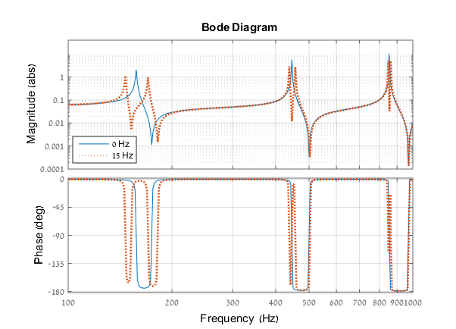

1. Frequency response function for theoretical model with properties given in Table II for rotation at frequencies of 0 and 15 Hz

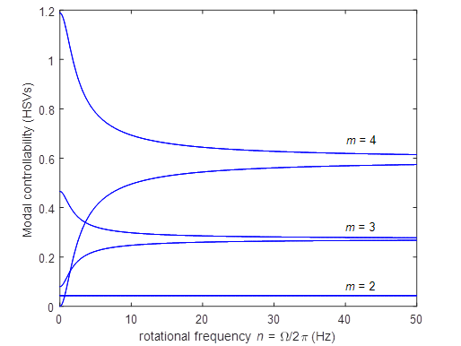

1. Variation in controllabililty (Hankel singular values) with rotational speed for case of two actuators separated by

# Experimental Evaluations

## A. System description

The theoretical predictions on the effects of actuator location and rotational speed were tested in the experiments performed. The main components of the experimental test rig are shown in Fig. 7. The system comprises a short (51 mm length) thin-walled cylinder with diameter 222 mm and wall thickness *d* = 3.1 mm. The cylinder was made from martensitic stainless steel (grade 420J2) with inner and outer surfaces formed by electric discharge machining. Further properties are given in Table II.

The method of supporting the cylinder includes two components: a soft silicone rubber tube and four foam rubber straps (90 degrees separation). These were attached to the outside of the cylinder and to the circular disk using glue. The space between the annular ring and the circular disc is 6 mm. The circular disk was fastened to a rigid shaft by a mechanical hub and rotated by a brushless d.c. motor. This architecture was designed to minimize the external constraints on the radial dynamics of the cylinder, so the behavior matches the theoretical model introduced is Section II. Two piezoelectric patch actuators of the type P-876A15 from Physik Instrumente were glued to the outside surface of the cylinder with 45-degree angular separation. Two piezoelectric sensors (PI P-876SP1) were glued to the inside surface, concentric with the actuators. The electric wires from the actuators and sensors exit from the rotating system through slip rings. The addition of the piezoelectrics has only small impact on the uncontrolled dynamics of the structure.

The data acquisition, analysis system and feedback control algorithm were implemented digitally with PC-based hardware. The sampling frequency was set to 8000 Hz for all tests.

## B. Experimental aims

The experimental results were obtained using the system architecture shown in Fig. 8. The control inputs and represent the driving signals for the piezo patch actuators (right and left in Fig. 7, respectively). The outputs and represent the corresponding collocated piezo patch sensor signals. System represent the dynamics of the cylinder and represent the controller. In the experiments, a single control feedback loop was applied via and . Testing of control effectiveness was additionally made through excitation from and measurement of . The control law applied was based on a synthetic proof-mass-damper transfer function, with parameters tuned to achieve active damping of the first three pairs of flexural modes (with wavenumbers ). The corresponding natural frequencies were 161, 443, 846 Hz for no rotation.

A key aspect of the experiment set up is that the angular separation of the actuators at 45-degrees is the best-case positioning for control of both modes with *m* = 2. However, it is the worst-case separation for control of the *m* = 4 modes (see Table I). This is because two inputs at 45-degree separation are effectively equivalent for the modes with *m* = 4. In other words, the two inputs act, in effect, as one input.

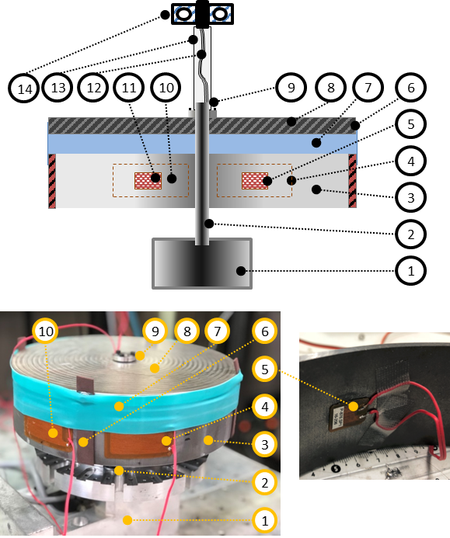

1. Test rig schematics: Cross-section (Top); Photograph (Bottom). Main components are 1, motor; 2, rigid shaft; 3, annular ring; 4, piezo patch actuator (right); 5, piezo patch sensor (right); 6, silicone rubber band; 7, soft annular silicone rubber; 8, circular disk; 9, mechanical hub; 10, piezo patch actuator (left); 11, piezo patch sensor (left); 12, electric wires; 13, plastic tube; 14, slip ring.

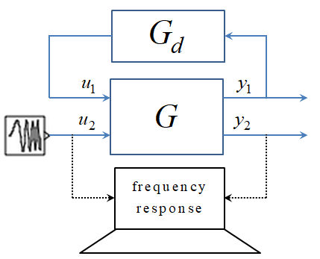

1. Verification architecture

Without rotation, it is anticipated that the input can easily excite modes that are not effectively controlled by the active damping feedback signal . Hence, for the mode that is not suppressed by the feedback signal will be evident by excitation through . However, it should also be observed that one of the modes with cannot be excited or controlled through either or .

According to the theoretical predictions, for non-zero rotational speed, the active damping control should couple with both modes in each pair with . For sufficiently high rotational speed, effective damping of all the modes with should be possible even though only one actuator is used for control.

*C. Control law implementation*

For the experiments, active damping control was implemented based on a second order proof-mass-damper transfer function that was tuned to provide effective damping for each resonance seen in the FRF of . The control law was based on the following continuous time transfer function:

1. Cofficients of control law

| Modes |  | |  | |
| --- | --- | --- | --- | --- |
|  |  |  |  |
| *m* = 2 | 0.0176 | 2π⋅171 | 0.0282 | 2π⋅181 |
| *m* = 3 | 0.0236 | 2π⋅470 | 0.0382 | 2π⋅474 |
| *m* = 4 | 0.0932 | 2π⋅899 | 0.1341 | 2π⋅903 |



This may be interpreted as derivative feedback in series with a second order resonant filter. A key aspect here is that the filter resonance is tuned to match the anti-resonance that occurs at a slightly higher frequency than the structural resonance of the cylinder. In this way, adequate phase advance and gain occurs in the control loop close to the resonant frequency. This provides effective damping but with fast roll-off for higher frequencies, which helps to avoid destabilization of high frequency modes that are not targeted by the control law. As the frequencies for resonance and anti-resonance of the cylinder vary with rotational speed, the control law must be tuned to match a specific value of .

Conversion to discrete-time is based on a direct pole-zero mapping so that, for each mode pair , a feedback control component is generated by operating on with :



where is the wavenumber, is the derivative gain and is a complex-valued z-plane pole that matches the anti-resonance (plant zero) occurring just above the mode natural frequency. If the s-plane zero corresponding to the anti-resonance is given by then



where is the sampling period .

The overall control law is given by the sum of the transfer functions in for each targeted mode:



Two different controller tunings were used for no rotation and for a rotational frequency of 15 Hz. The filter damping ratios were set to 0.01 and the derivative gains were set by empirical tuning. The anti-resonance values were taken from the frequency response measurements, as shown in Fig. 9. The coefficients of the control law are given in Table III.

*D. Experimental results*

Fig. 10 and Fig. 11 show the measured frequency response from to with and without control for cases of no rotation and for a rotational frequency of 15 Hz, respectively. For the closed loop system, increased damping is evident for all the modes excited through , for both the non-rotating and rotating cases.

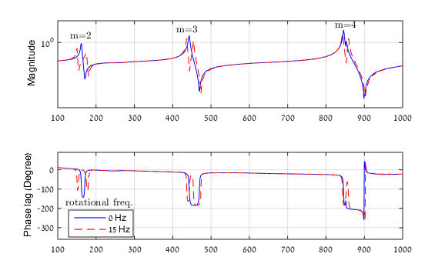

1. Frequency response mesaurements without feedback control for no rotation and rotation with frequency 15 Hz

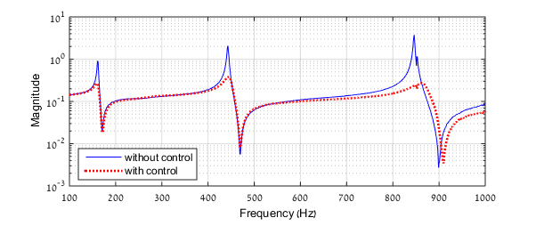

1. Frequency response measurements without control and with closed loop control for 0 Hz rotational frequency

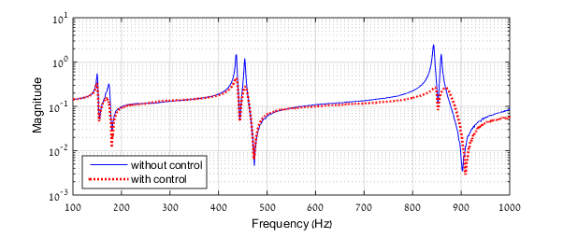

1. Frequency response measurements without control and with closed loop control for 15 Hz rotational frequency



0 Hz

15 Hz

1. Frequency response measurements with feedback control applied using and : Two cases are shown for 0 Hz and 15 Hz rotational frequency

Fig. 12 shows the measured frequency response from to for the same controlled cases shown in Fig. 10 and 11. The results here match the theoretical predictions on the effect of actuator location. For the and mode pairs, a resonant excitation of the mode that is not controlled by actuator 1 is evident for the non-rotating case. However, with rotation, the resonance disappears and effective damping of each mode pair (now having distinct natural frequencies) is achieved. For the modes, there is no resonance evident, either with or without rotation. This is consistent with the theoretical prediction that, in the non-rotating case, only one mode is excitable by actuator 2 and that mode is well controlled by actuator 1. The mode that is uncontrollable with actuator 1 is also unexcitable by actuator 2.

# Conclusion

The results in this paper show that, for a rotating cylinder, only one actuator is required to achieve active damping of vibration modes involving circumferential travelling waves. For systems that operate over a range of rotational speeds, however, multiple actuators may still be required to give effective damping at low or zero speed. Further work will address the explicit optimization of actuator/sensor placement in combination with MIMO controller design.

References

1. Lord Rayleigh, *The Theory of Sound*, Cambridge University Press, 1877.
2. A. Love. *A Treatise on the Mathematical Theory of Elasticity*, Cambridge University Press, 1906.
3. Y. Xing, B. Liu, T. Xu, Exact solutions for free vibration of circular cylindrical shells with classical boundary conditions, *International Journal of Mechanical Sciences*, vol. 75, pp. 178-188, 2013.
4. N. Alujević, N. Campillo-Davo, P. Kindt, W. Desmet, B. Pluymers, S. Vercammen, Analytical solution for free vibrations of rotating cylindrical shells having free boundary conditions, *Engineering Structures*, vol. 132, pp. 152-171, 2017.
5. W. Soedel, *Vibration of Shells and Plates*, Marcel Dekker, New York, 2004.
6. G. Genta, *Dynamics of Rotating Systems,* Springer Science Business Media, Inc., New York, 2009.
7. M. Endo, K. Hatamura, M. Sakata and O. Taniguchi, Flexural vibration of a thin rotating ring, *Journal of Sound and Vibration*, vol. 92, no. 2, pp. 261–272, 1984.
8. M.O.T. Cole, W. Fakkaew, An active magnetic bearing for thin-walled rotors: vibrational dynamics and stabilizing control, *IEEE/ASME Transactions on Mechatronics,* vol. 23, no. 6, 2018, pp. 2859 – 2869.
9. S. V. Canchi, R. G. Parker, Effect of ring-planet mesh phasing and contact ratio on the parametric instabilities of a planetary gear ring, *ASME* *Journal of Mechanical Design*, vol. 130 pp. 014501-1-6, 2008.
10. T. Lu, A. Tsouvalas, A.V. Metrikine, The in-plane free vibration of an elastically supported thin ring rotating at high speeds revisited, *Journal of Sound and Vibration*, vol. 402, pp. 203-218, 2017.
11. K. Mehdi, J.-F. Rigal, D. Play, Dynamic behavior of a thin-walled cylindrical workpiece during the turning process, part 2: experimental approach and validation, *ASME Journal of Manufacturing Science and Engineering*, vol. 124 pp. 569-580, 2003.
12. Kwak, M. K., Heo, S., & Jeong, M. Dynamic modelling and active vibration controller design for a cylindrical shell equipped with piezoelectric sensors and actuators. Journal of Sound and Vibration, vol. 321, 510-524, 2009.
13. Ashish Kumar, M.C. Ray, Control of smart rotating laminated composite truncated conical shell using ACLD treatment, *International Journal of Mechanical Sciences*, vol. 89, pp. 123-141, 2014.

1. *Research supported by Thailand Research Fund and Chiang Mai University [Grant BRG5980013].

   M. O. T. Cole is with the Department of Mechanical Engineering, Chiang Mai University, Chiang Mai, Thailand (phone: +66 53 944146; fax: +66 53 944145; e-mail: motcole@dome.eng.cmu.ac.th).

   Z. Brand is with the Department of Mechanical Engineering, Chiang Mai University, Chiang Mai, Thailand (e-mail: brand.ziv@gmail.com).